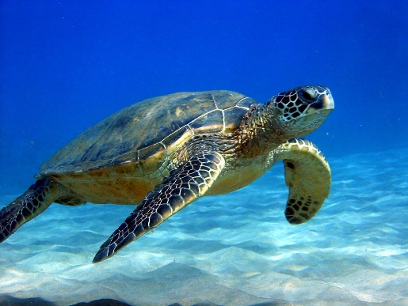
Dear George
I know you cannot read this but mom said I had to make you one. You are a great cat. You don’t usually eat birds and you get rid of the mice really well. Merry Christmas.
Dear Dad
You are a great dad and I hope you have a merry Christmas this year. You are understanding and you help me with Basketball and swimming. You also help me with my crazy ideas in the woods. Have a very merry Christmas.
Dear Mrs. Brewer
I hope you get well soon. We all miss you here. We are telling the new kids about you and your fun games. I miss your spirit and your fun nature. Nothing is the same without you here.
Dear Meeka and Grandpa
You two are the best grandparents anyone could have; I hope you have a merry Christmas. Meeka thank you for teaching me stuff with the camera and how to bake pies. Grandpa thank you for taking me and Alex on adventures and boat races. Have a very merry Christmas.
Dear mom
You are a great mom and I hope you have a merry Christmas this year. You are always there for me, even when I’m on the other side of the US . You put up with my crazy ideas, and my adventures. Have a very merry Christmas.

